Observe les noms d'aliments ci-dessous.
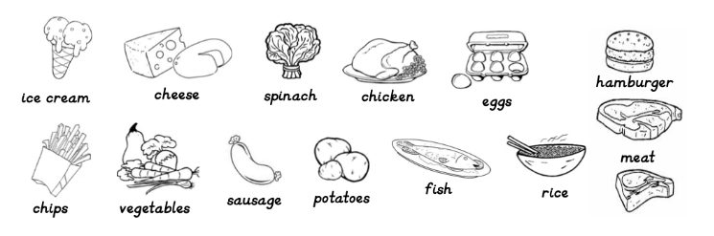

- I want
- My dad likes
- I don't like
- I prefer
- Nina eats
- The teacher loves

